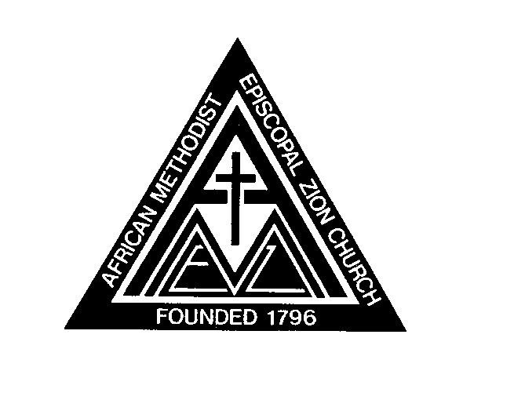
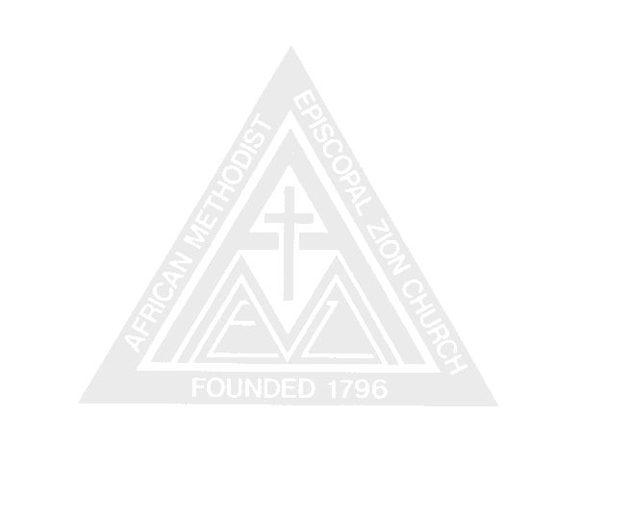
African Methodist Episcopal Zion Church
RECORD OF DEED

Conference
Name of Church
Location of Church
City County
State
Date Made
Date Filed
Page County

Register of Deeds

Date
Note: Form should be completed and sent to: General Secretary-Auditor
P.O. Box 32843, Charlotte, NC 28232

