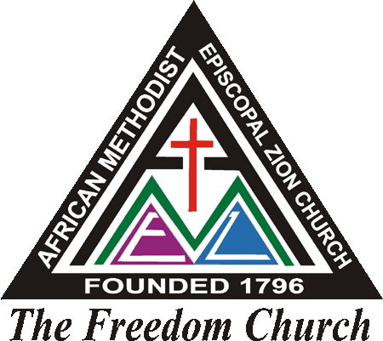

***Pastor’s Welcome Letter***

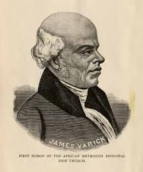

Dear      :

Grace, Mercy & Peace from God our Father and our Lord and Savior Jesus, the Christ. Welcome!!!

We are excited that you have allowed us to share in your journey of growing in the Kingdom of God as a member of the *African* Methodist Episcopal Zion Church. What a joy it is to have you as a vital part of our church! You'll discover that our passion is to provide a place where people, just like you, can have a life-changing experience with God.

Our doors are wide open to people from all backgrounds, regardless of where they are on their spiritual journey. We don’t expect anyone to show up a perfect Christian, and certainly there are no perfect people here. We admit we need God and each other to fulfill our God given destinies. Come as you are and join in our powerful worship services that offer biblical truth in practical ways. We believe that God has called us to be on mission with Him. And as we strive to become more effective followers of Christ, we pray that you will continue with us on our spiritual journey.

It won't take you long to discover that we're more than just a Sunday church. In fact, our goal is to advance the Kingdom of God through Worship, Word, Witness, Worth and Work. If you'd like to develop authentic and enduring relationships with others, you'll be glad to know there are opportunities to do so by joining a network group (Class) or one of our many active ministries. Your class leader’s name is:      . Her contact information is:      .

To aid you in becoming more familiar with the members and ministries of and to become active in ministry, we would like for you to join us in our new member’s orientation class Sunday mornings. Our Assimilation Minister,      will be in touch with you. In the meantime, you may contact him at:      .

If I can be of further assistance, please feel free to call me at:      or by email at:

Finally, on my and Lady      behalf, we pray that the blessings of the Lord will continue to enshroud you in His grace and mercy.

In and for the Sake of the Kingdom, I Remain:

Committed to Advancing the Cause of Christ,

___________________________________________________

The Reverend      Pastor/Servant Leader